FLYTER DRONE SERVICES
(Unbox Your Happiness)
Marketing Department

OMDEEP MALAKAR- Head of Marketing Department (Team- MARS)

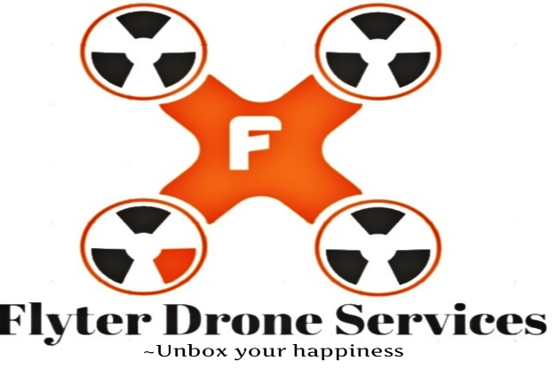

Case Understanding:

As, of today's technological ERA a courier company decided to venture in "Hyper local Delivery space” & trying to conduct deliveries in more convenient & Fastest mode. According to the rules, company already has permission from Director General of civil Aviation (DGCA) for Flying drones.

It has conducted successful trials of deliveries. Now, company trying to build an end-to-end Drone operations & Management platform through which a rapid scaling of business can be achieved.

Now the company is trying to do the Marketing of their drones services. Marketing of drone services is important so that everyone will get to know about our products. The services that we offer. Company is trying to reach as many customers through Advertising and promotion of our drone services.

BSC SUMMARY:

As company has decided to venture into drone delivery system it is necessary to understand the new generation of drone delivery services, it is important that customers are aware with our products and services that we offer.
Doing
At the highest level, advertising is about creating a pattern of association. But the best advertising creates a genuine association. The goal of drone advertising is to get people to hire your service or buy your product, simple as that. If no one knows about your company (and, perhaps more importantly, the benefits of what your company does)
We have mostly focused on:

- marketing strategy
- marketing mix
- marketing plan

Our Vision Statement:
Our vision is to become a leading Brand in the commercial drone delivery services line of business in India.

Our Mission Statement:
Our mission is to provide faster and reliable means of delivering parcels via drones. We want to build a commercial drone delivery services company that can favorably compete with other leading brands in the commercial drone delivery services industry both in India and in other parts of the world.

OUR SERVICES OFFERING:
Delivery is in the commercial drone delivery line of business to maximize profits, and we are going to do all that is permitted by the law in India to achieve our business goals.
We will engage in transporting medicines and vaccines, and retrieving medical samples, into and out of remote or otherwise inaccessible regions and transporting packages, food or other goods via our reliable drones.

DRONE DELIVERY SERVICES:
Two service options exist; Depot to Depot which is focused on rural applications providing services from warehouse to warehouse and Depot to Consumer offering logistics services from a retailer / warehouse direct to a consumer home or business location.
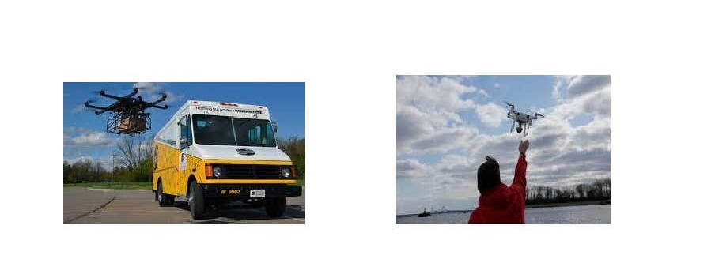

DEPOT TO DEPOT DRONE DELIVERY:
Delivery offers a Depot to Depot drone delivery logistics solution. This logistics delivery solution is ideal for pan areas of Mumbai in which goods are transported to and from distribution warehouses / locations.

Applications for this next generation service are limitless which can include;

- Rural Community Supplies Transport (goods, food, medicine, etc.) Bulk Mail Shipments (sorting facility to post office)

- Emergency Aid (first aid, defibrillators)

- This technology is an ideal means to effectively move goods from "Point A to Point B" quickly, cost effectively in sparsely populated areas where traditional delivery methodologies are prohibitive due to cost or geographical restraints.

DEPOT TO CONSUMER DRONE DELIVERY:

Delivery offers a Depot to Consumer drone delivery logistics solution. This logistics delivery solution provides just in time delivery service from a retailer / warehouse to a home or business.

Applications for this next generation service are limitless which can include;

- Food Delivery

- Retail Goods

- Service Parts

- Emergency Road Side Assistance

This technology is a revolutionary logistics platform which offers just in time goods delivery from a centralized depot to almost limitless end points which include but are not limited to; consumers home, business, cottage, boat, park, or on the side of a road.

FEATURES OF DELIVERY:

- Tap to fly: a feature which puts the drone on autopilot with a single tap

- Visual Tracking of the drone's movements

- Sport Mode: 25% more speed than in any other modes and the same stability

- Extended Flight Time: you can get up to 28 minutes in the air but this depends on the load on the drone.

Understanding marketing mix of Flyter Drone Services:

The marketing mix is the mixture of factors you can control and manipulate in order to achieve your marketing strategy. These are usually broken down into the Four Ps:
- Price,
- Product,
- Place,
- Promotion.

Price is the literal price of the good or services.
Your product is the thing you’re trying to advertise.
The Place is the point of sale (which more often than not is now a website instead of an actual physical location.)
The Promotion is what we typically think of as advertising

OUR TARGET MARKET:

We are aware that drone delivery business is pretty much green and would require innovative marketing approaches.
Our target market cuts across hospitals that need delicate blood samples or medicines.
We are in business to services the following people and organizations;
- Households

- Corporate Executives

- Business People

- Corporate organizations

- Grocery stores

- Fast food restaurant

- Post office

MARKETING STRATEGY AND SALES STRATEGY:

- Delivery will adopt the following sales and marketing approach to win customers over;
- Open our Flyter drone delivery services business in a grand style with a party for all.
- We will Introduce our flyter drone delivery services business by sending introductory letters alongside our brochure to organizations, households and key stake holders in and around India.
- Position our signage / flexi banners at strategic places arounid India.
- Position our greeters to welcome and direct potential customers.
- Create a loyalty plan that will enable us reward our regular customers
- Engage on roadshows within our neighborhood to create awareness for our Flyter drone delivery services business.

PUBLICITY AND ADVERTISING STRATEGY:

- Place advertisement on community based newspapers, radio and TV stations
- Encourage the use of word of mouth publicity from our loyal customers
- Leverage on the internet and social media platforms like YouTube, Instagram, Facebook, Twitter, LinkedIn, Snapchat, Google+ and other platforms to promote our business
- Ensure that our we position our banners and billboards in strategic positions all around India.
- Distribute our fliers and handbills in target areas in and around our neighborhood
- Advertise our drone delivery services business in our official website and employ strategies that will help us pull traffic to the site.

- Brand all our drones, official cars and trucks and ensure that all our staff members and management staff wear our branded shirt or cap at regular intervals.

Advertising Our Flyter Drone Services:

We often think of advertising as taking the form of literal advertisements – promoted Facebook posts, Google AdSense ads, the stuff they make you watch in movie theaters before the main event, etc.

But advertising can be the word-of-mouth information people spread about your business, or reviews of your products on prominent websites, or YouTube vlogs people make about you.

You’ll notice that most of those examples involved the Internet in some way, which is why the first step of any drone advertising campaign has to be building a website. After that, you’ll want a marketing strategy, marketing mix, and marketing plan for your drone company.

OUR PRICING STRATEGY:

- At Delivery we will keep the prices of our services below the average market rate for all of our customers by keeping our overhead low and by collecting payment in advance from corporate organizations who would steadily bring in loads of parcels to be delivered via drones to their large clientele base.

- In addition, we will also offer special discounted rates to all our customers at regular intervals.

Conclusion:
Delivery drones are arguably one of the most important and useful technological advances humanity has made. They aren't only online shopping delivery drones. drones do much more than just deliver amazon packages, they can deliver other goods, save people in danger, monitor damage and large gatherings, as well as support in the execution of rescue missions. Delivery is a big part of practical drone usage, but drones are capable of many more complicated tasks, all of which affect everyday life.
So our company has tried their best to reach out to our customers and provide them the best , smooth and fastest delivery services.

